Tamweel Temenos Advanced Collections
Tawarruq Unit Testing


Contents
Collection Module 2
Collector Search Options 3
Queue All search option 3
Queue by Amount Range 3
Queue by Status 3
Customer Name 3
Account Number 3
Product 3
Employee Name 3
Supervisor Search options 3
Accounts for review 3
Sv by Employee 3
CMS Screen 4
Customer general information 4
Account Snapshot (gap customization) 4
Account Details (gap customization) 4
Contacts 4
Collection 4
Promise scheduling 4
View Transactions 5
Common Action Panel 5
Notes 5
Action Code History 6
Litigation 6
Business Rules 8
Criteria Fields 8
Schedule 9
Actions 9
Allocation 10
Application Setup LOVs 10
System Tables 10
Action Codes 10
Standard Notes 12
Communications 13
Managing SMS Templates 13
Workforce 16
My Profile 16
Managing Messages 17
Review Received Messages 17
Create New Message 18
Review Sent Messages 18
Managing User 18
Search User List 19
Managing User Profile 19
Setting Up User Personal Details 20
Managing User Permission and Other Security Details 21
Managing Organization Membership 22
Managing Search and Pool Access 22
Assigning User Actions Access 23
Monitoring Login History 23
Managing Dashboard Widget Access 24
Managing Template Access 25

Collection Module
In this module, there are details and snapshots for the functionalities under the collections module which mainly include search options and CMS screen
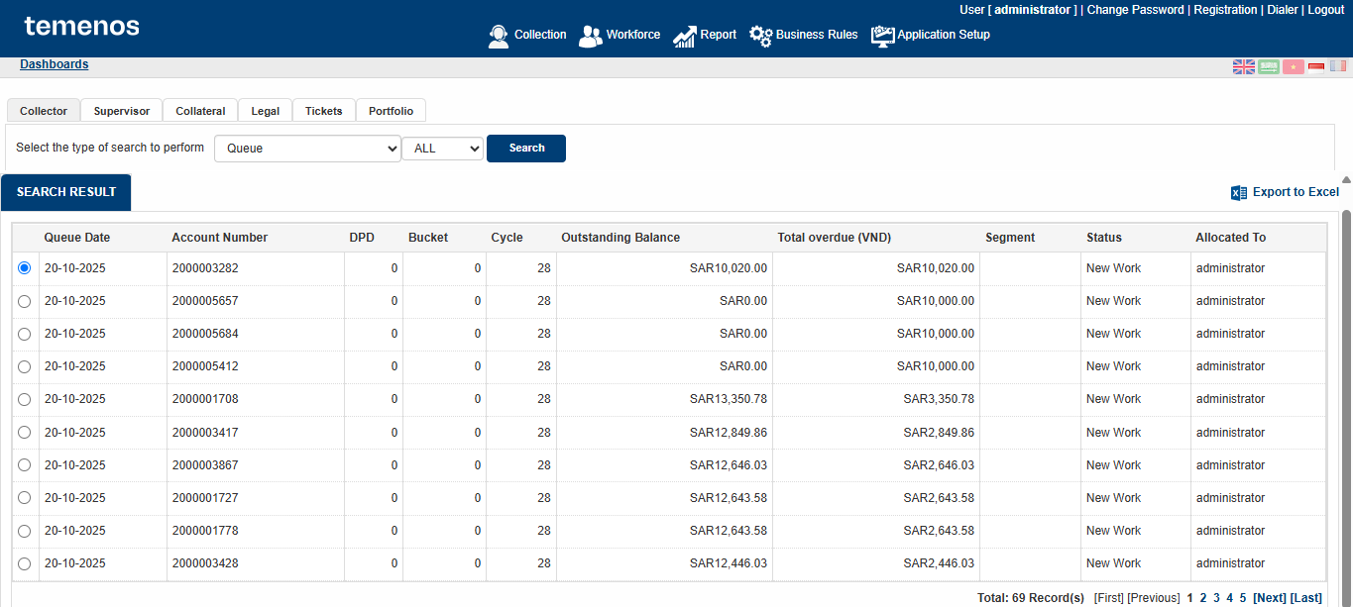

Collector Search Options
The Collector search options are available through this navigation:
Login > Collections > Collector

Queue All search option
This search option is displaying all the accounts allocated to a user through manual or automated allocation.
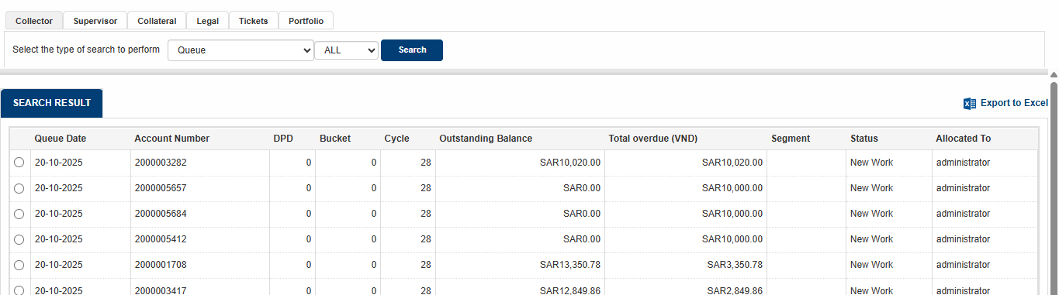

Queue by Amount Range
This option is displaying accounts as per their overdue balances range.
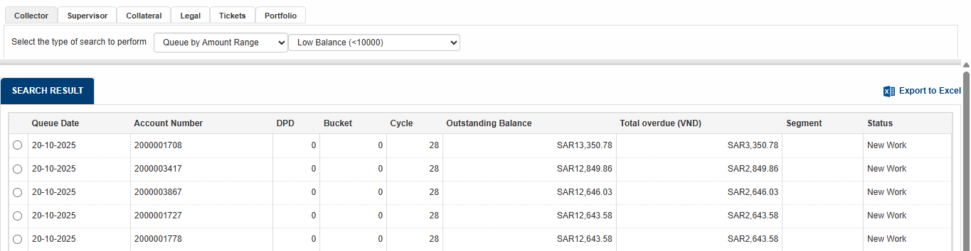

Queue by Status
This search option displays the accounts as per their current user defined status.
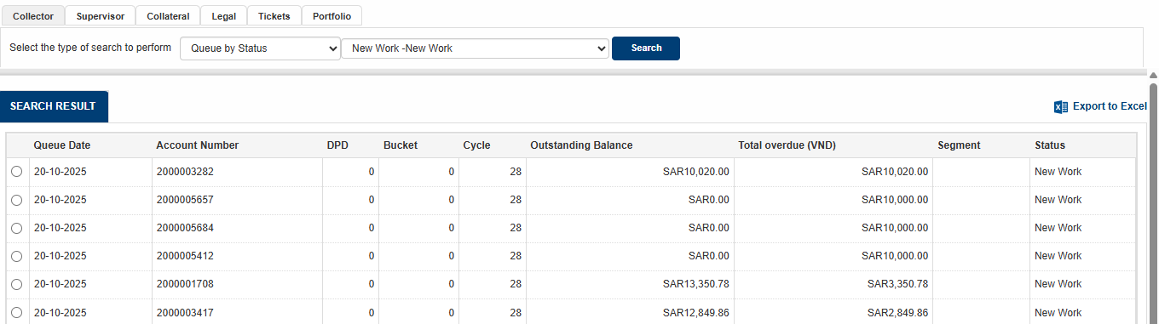

Customer Name
This search option is displaying the accounts based on the name of customer.
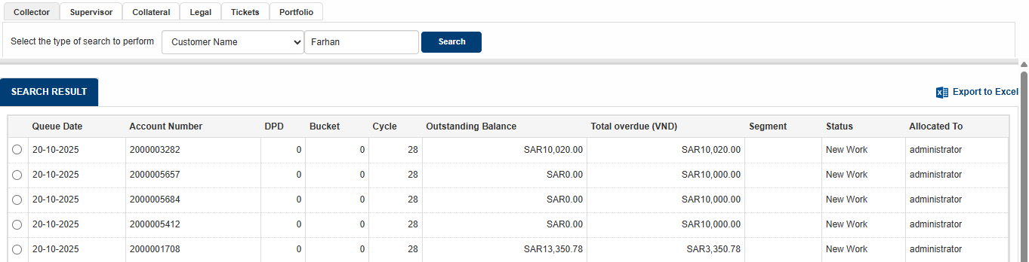

Account Number
This search result is displaying account when searched through the account number coming from LM.
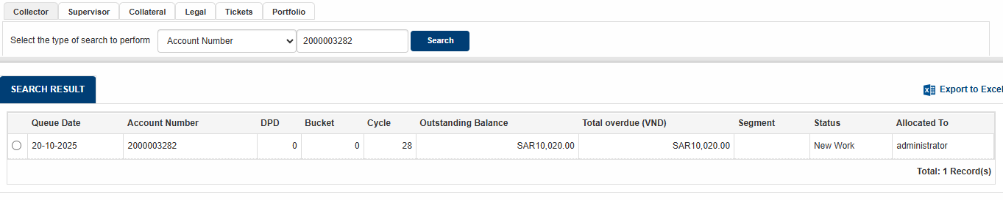

Employee Name
This search option is displaying the accounts with respect to the employee’s name to whom the accounts are assigned.
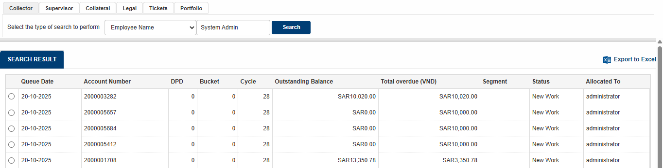

Supervisor Search options
The Collector search options are available through this navigation:
Login > Collections > Supervisor
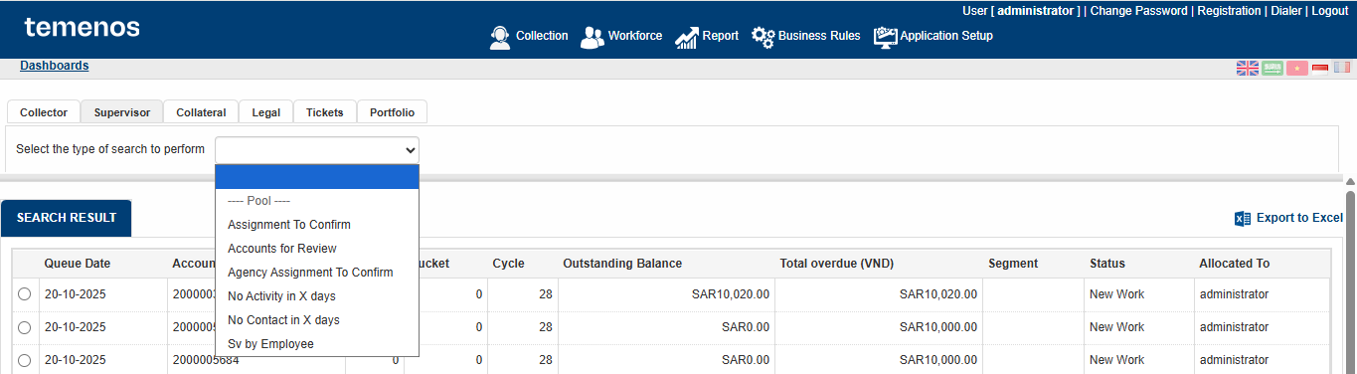

Accounts for review
This option displays the accounts which are referred to the supervisor by any collector.
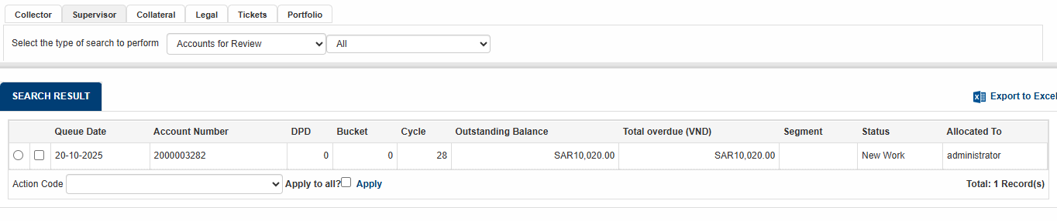

Sv by Employee
This search option is displaying the accounts for any specific collector chosen by the supervisor in criteria.
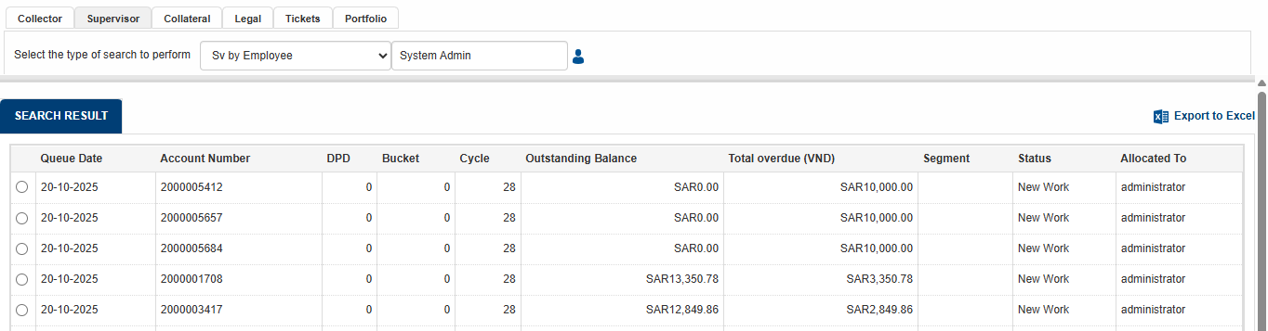

CMS Screen
You can navigate to CMS screen clicking Collector and choosing any search criteria. For example, in the snapshot below, Queue Search All option is chosen which displays all the accounts in collector’s queue.

The user can then click on any account it wishes to work by checking the circle and account’s CMS screen will open
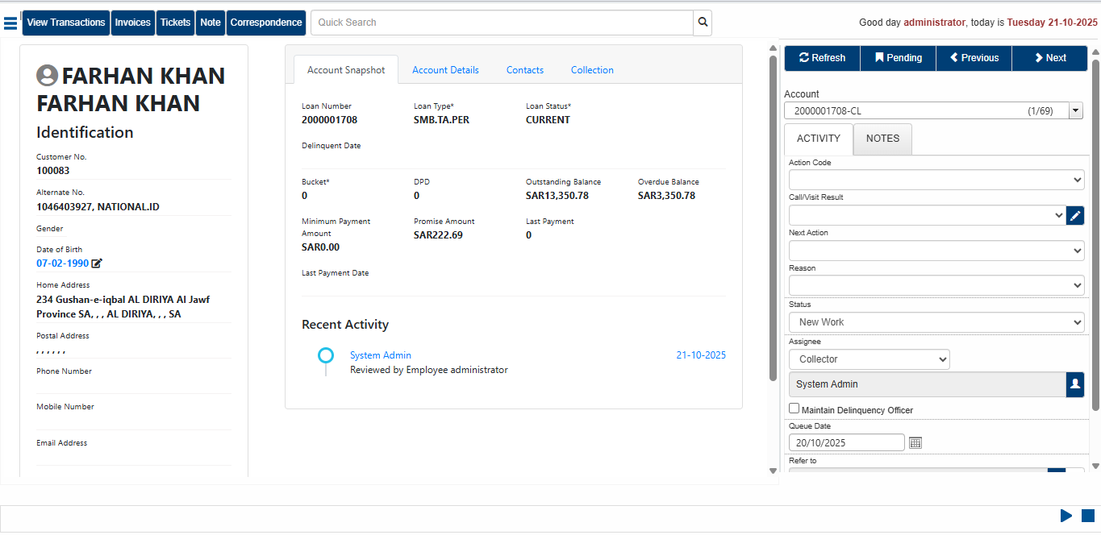

Customer general information
The tab below is displaying general information of the customer like gender, mobile number, date of birth etc. which are extracted from transact
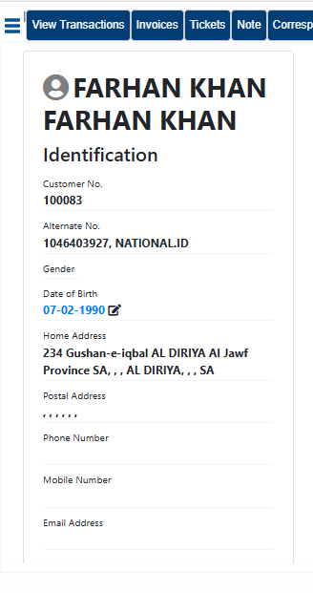

Account Snapshot
Below is the Account Snapshot which displays account summary and trail of recent activities performed on the account.
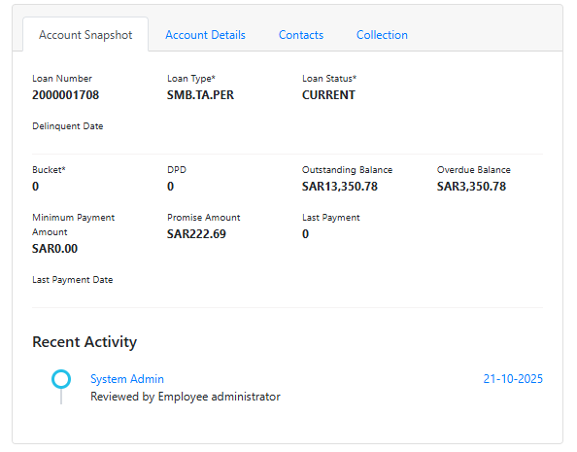

Account Details
This tab displays details for the financial information of the account as shown below:
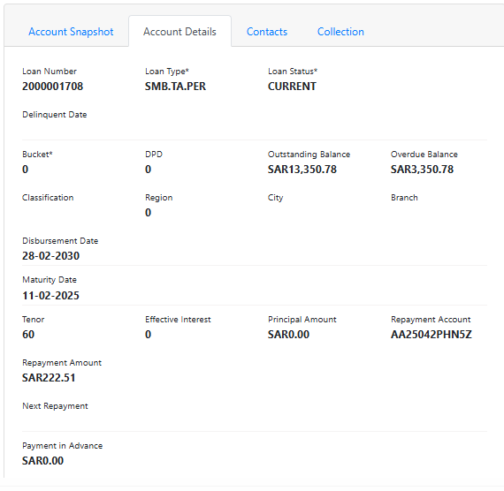

Contacts
This tab displays the contact information of the customer.
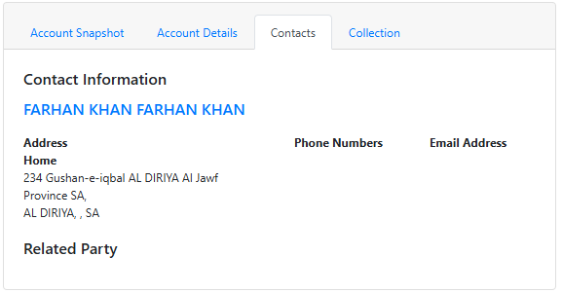

Collection
This tab displays the bucket movement of the customer along with frequency for each bucket and promise to pay details.
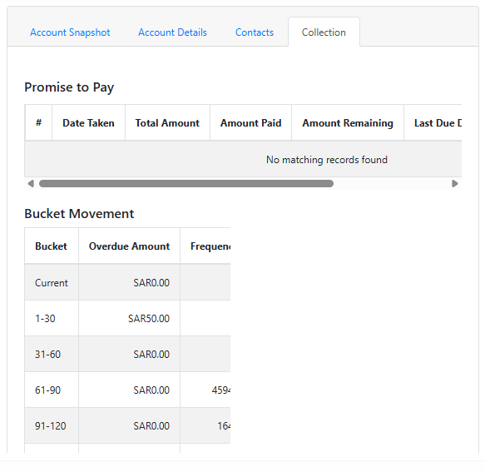

Promise scheduling
The promise is scheduled through:
Menu > Schedule Promises
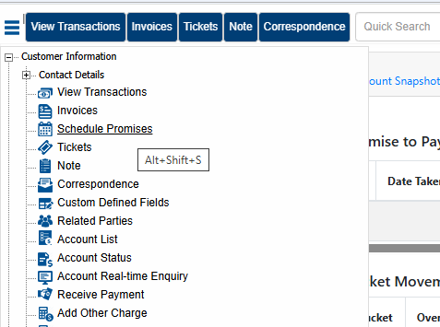
The amount for the Promise is entered in the Promise to pay field. Starting date means the due date of the promise. For option specifies the frequency if the promise needs to be scheduled.
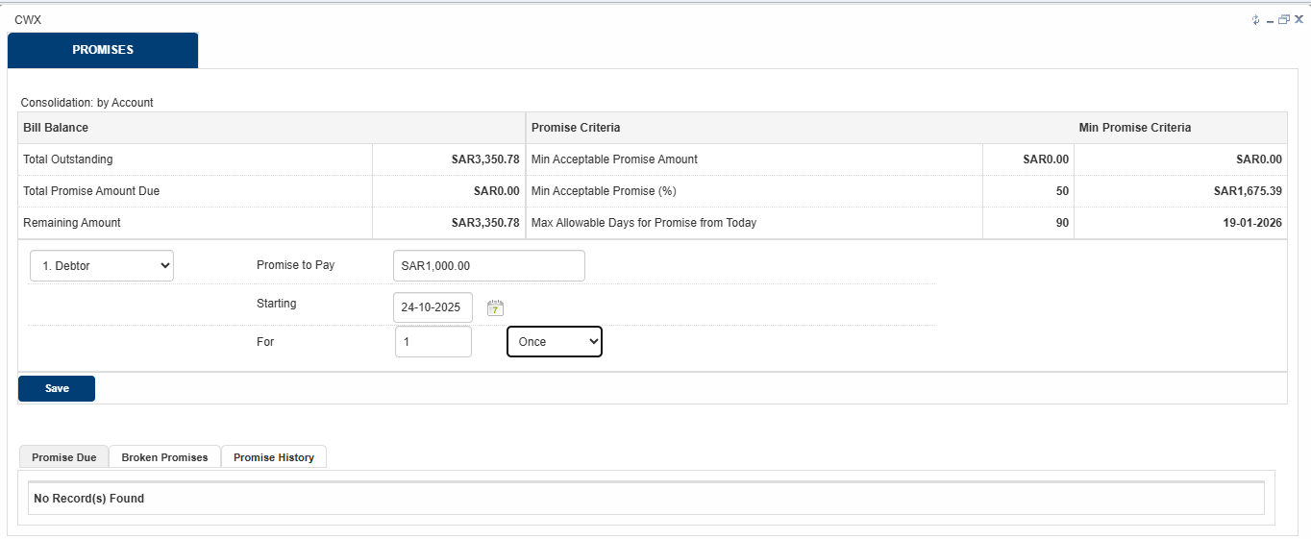

View Transactions
The View Transactions screen is there to view the financial transactions happened on the account. It displays the historical transactions as well. It can be navigated through the top left corner of the CMS screen as shown below:
As per the default functionality, the transaction data is uploaded here on day-1 incremental basis.
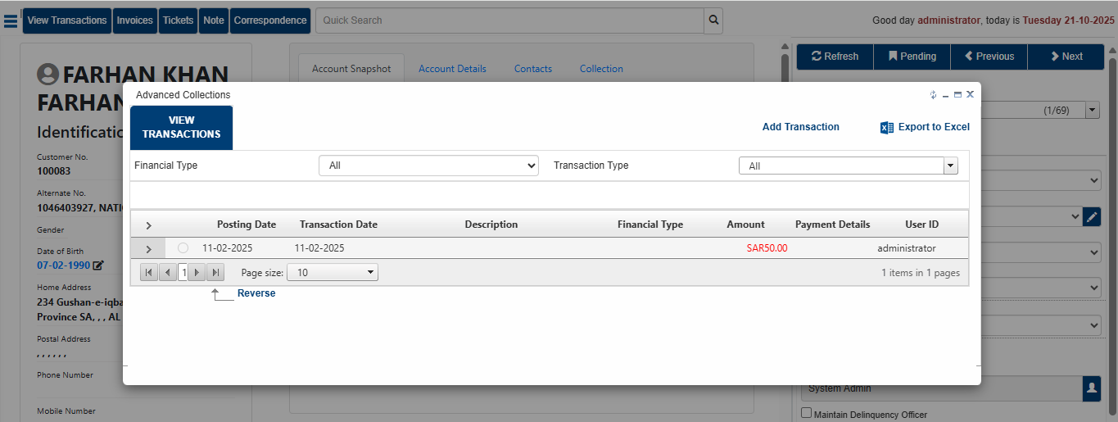

Common Action Panel
The common action panel on the right side of the CMS is used to perform activities by the user on the loan account. Here the user can mark Action codes, call results, next actions and reason codes. This panel also displays the TAC user defined statuses. The user can also update the queue date and refer the account to its supervisor. The supervisor would also have the access to change the assignee from the common action panel manually if required in some scenarios.
Make sure to click Save after performing any action in the common action panel. Else, the updates would not be saved.
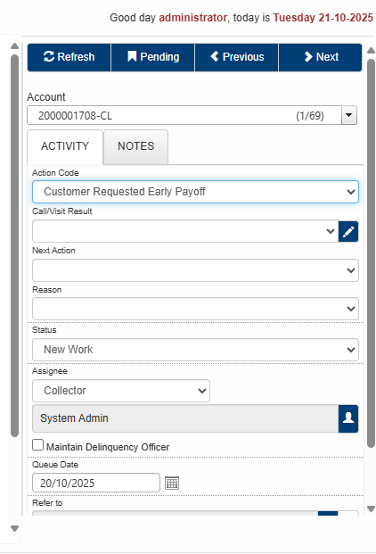
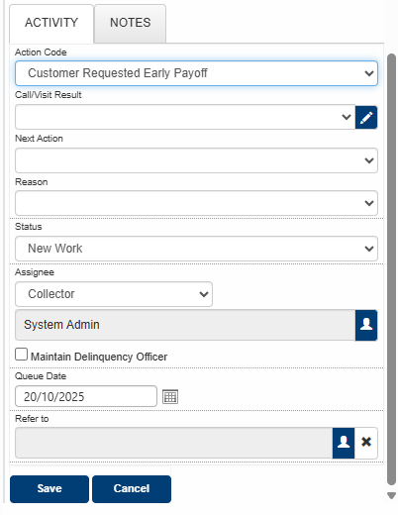

Notes
The notes can be added from user in common action panel under the Notes tab. Here the user can write manual notes, choose standard notes from the drop down or write a hot note as well which remains there on the screen.
The Standard and Manual notes disappear from this section after clicking save. These notes can be found in the Note option in the quick menu bar on the top left corner of the CMS.
This screen would display the trail for all the notes added on this account till date along with the user time and date. The user can search any particular note, add a new note from this screen or even edit already existing notes given the access is provided to the user. Notes are very important to follow, especially for collaboration among users.
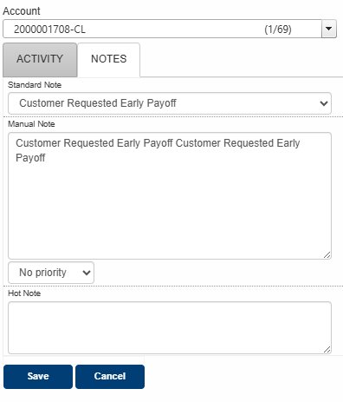
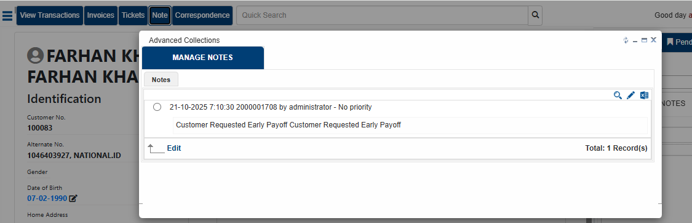

Action Code History
The user can also view the history or trail of all the action codes marked on the account by all the users till date. These options can be found in the top left corner menu as shown below in the snapshot.
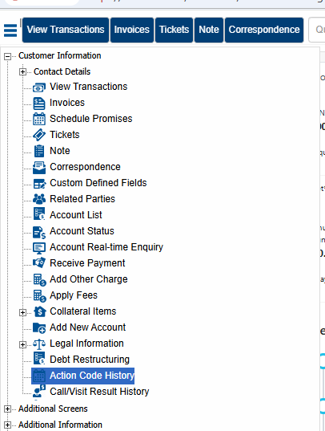
These screens display the username, date, time and description of the action codes marked till date.
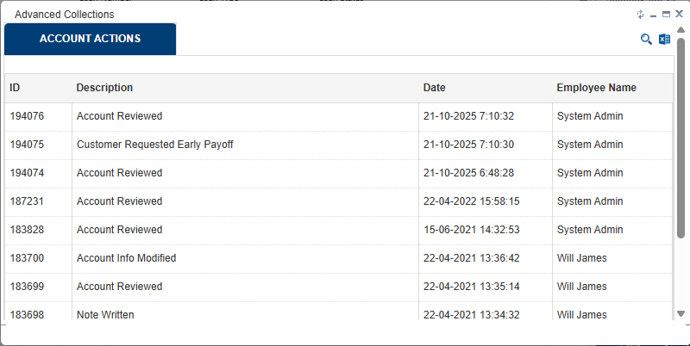

Litigation
The user can perform legal activities on a custom screen containing all the required fields. This screen can be navigated on CMS as per below:
Menu > Additional Screens > Legal
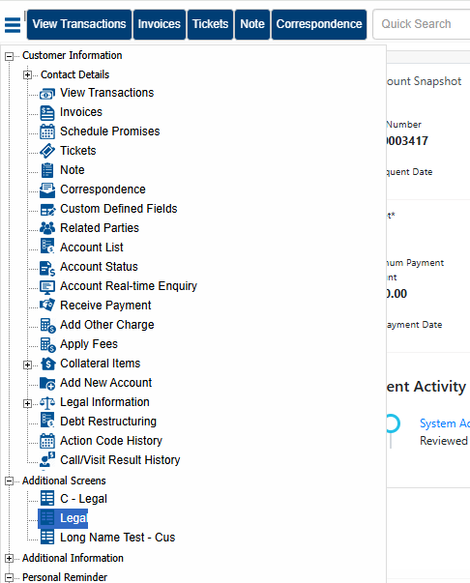
The legal user can enter all the required legal details on one screen as per the requirement. To initiate a new legal case, the legal user can click on “Add New Item” option on the screen
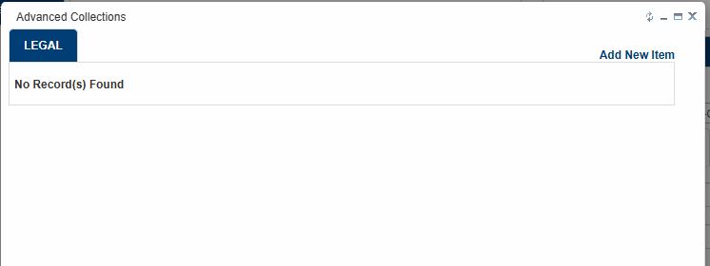

Here the user can enter all the required legal information.
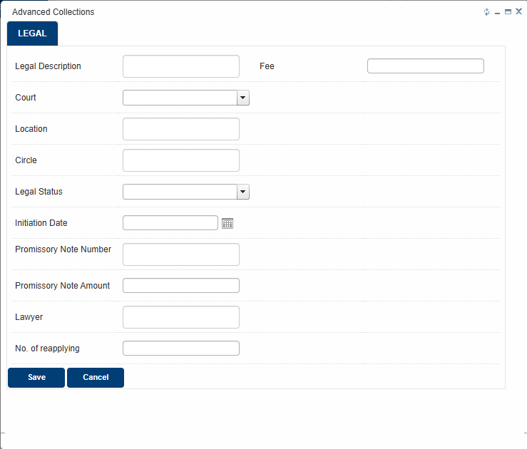
Upon saving, there is an entry created for this record which can be re-open to edit or resume legal proceedings.
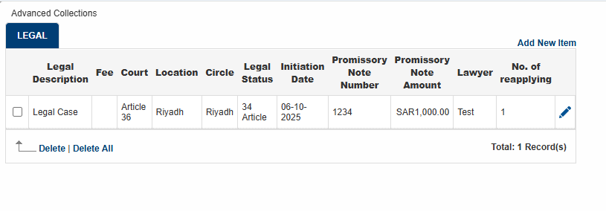

Business Rules
Business Rules are created for automating the allocation, sending payment reminders to customers and even referring bulk accounts to customers. Rules are created for Correspondence category. All the required rules and new rules should be created in Daily Routine Rules.
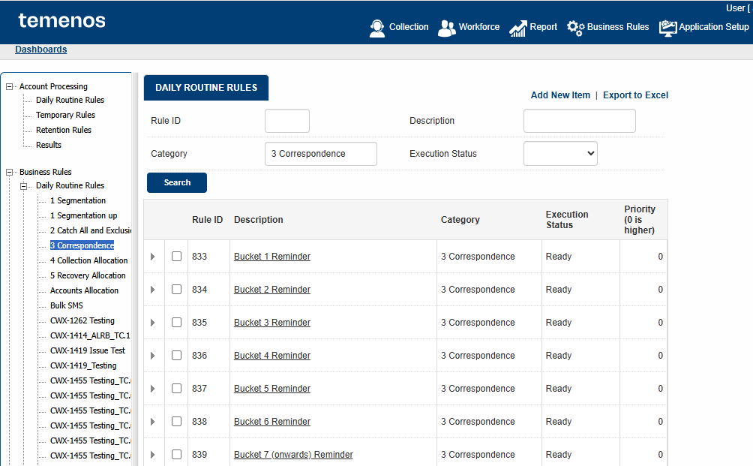

Criteria Fields
This is where the criteria are set for the business rules to extract the required accounts. As per the requirement, DPD is set as criteria to send reminder SMS.
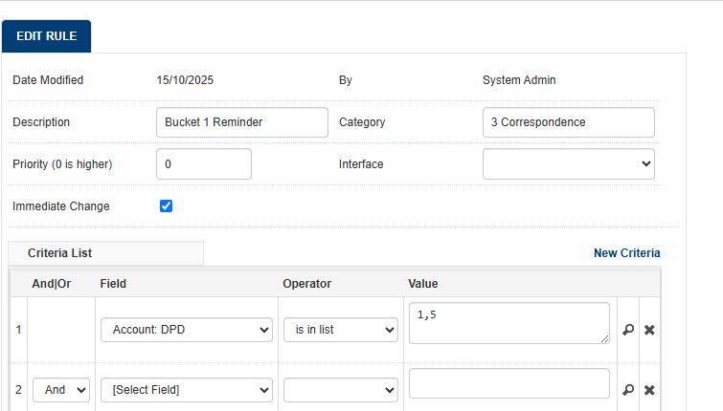

Schedule
The Schedule section allows you to define when the daily routine is available to be processed.
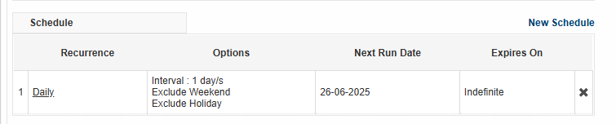
By default, a new daily routine rule is scheduled to run every day excluding the weekend and holiday, and will not expire. To schedule a rule, click the New Schedule button. Click the underlined recurrence description to edit the existing schedule.

Actions
The Actions section allows you to define different automated batch action to perform on accounts filtered by rule criteria. Here the ‘Request SMS’ action is set along with the relevant template for the business rules accordingly.
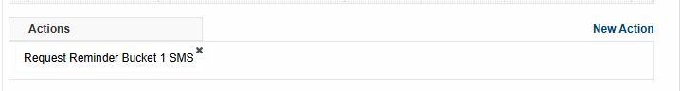

Allocation
The Allocation section allows you to define the allocation routine of accounts to collectors.
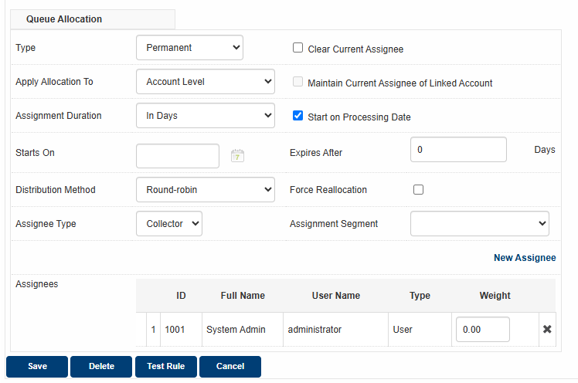

Application Setup LOVs

System Tables

Action Codes
Action codes are configured through following navigation:
Application Setup > System Tables > Action Codes > Add New Item
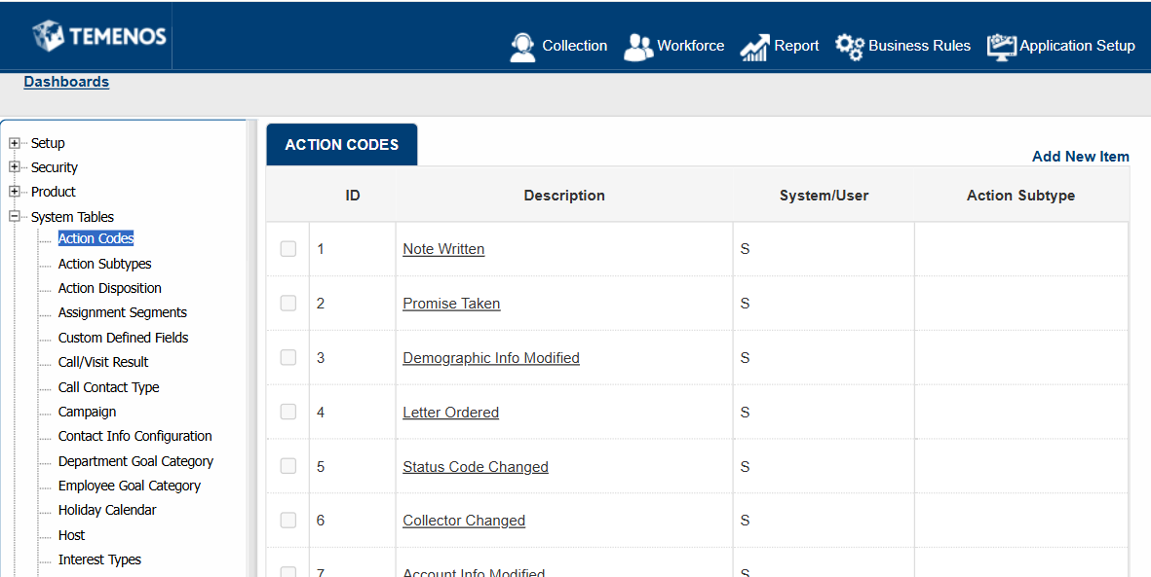
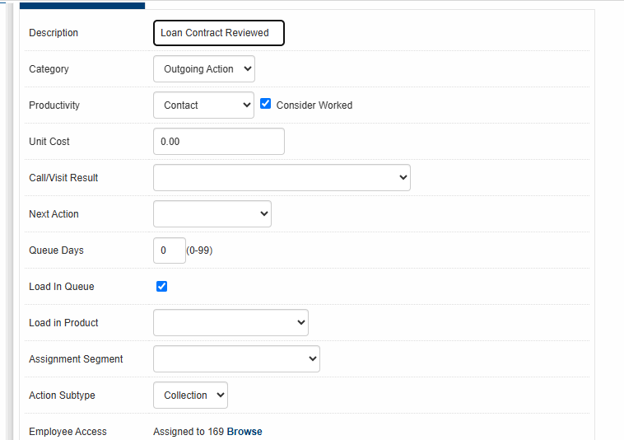
Here is a snapshot of the required action codes which are configured in Application Setup:
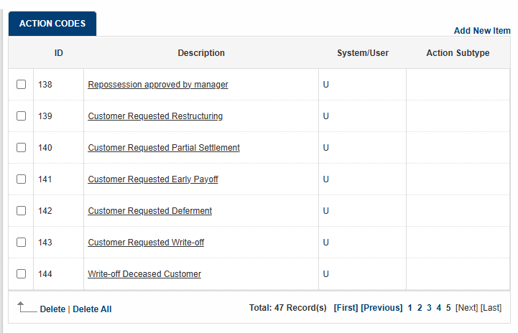

Standard Notes
Standard Notes are configured through following navigation:
Application Setup > Setup > Standard Notes > Add New Item
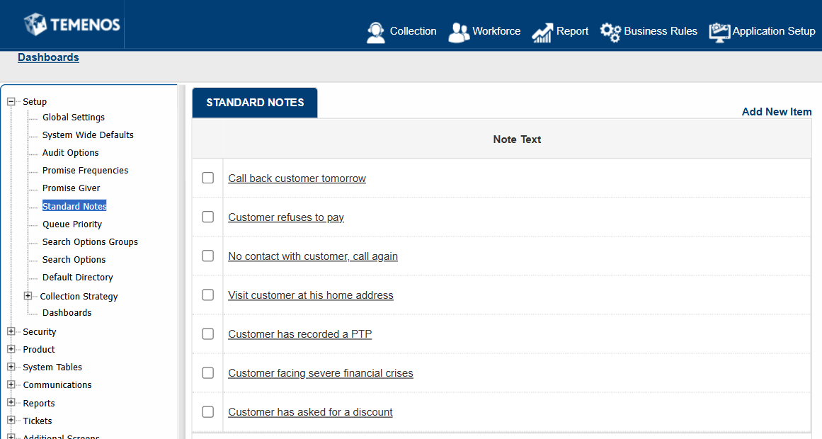
Here is a snapshot of the required standard notes which are configured in Application Setup:
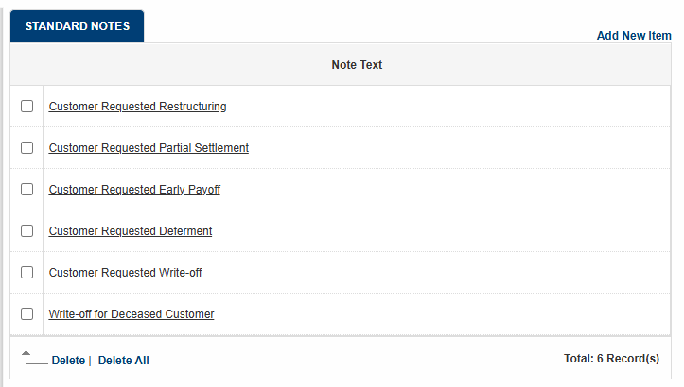

Communications
This is where SMS templates are configured in Application Setup.

Managing SMS Templates
This setup allows User to set SMS templates which can be used as:
• Correspondence SMS on CMS Module
• Correspondence SMS on Business Rule Module
To set email templates:
1. Go to Application Setup>Communication>Correspondence Templates>SMS.
2. [Document Definition] screen will be displayed.
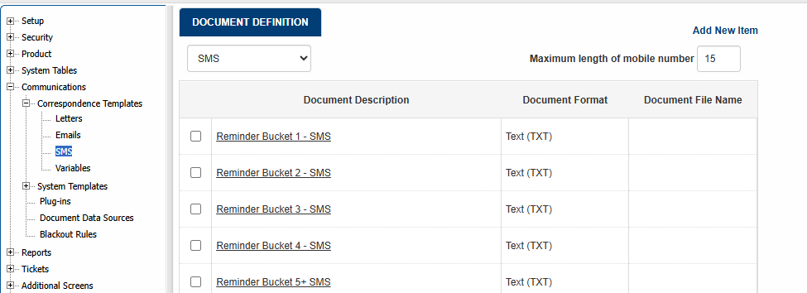

HTML Based SMS Template
This template type can be developed on screen by using HTML Design. Since SMS is plain-text base, not all formatting of HTML is available to SMS template. To develop the template:
- On [Document Definition] screen, click on [Add New Item] hyperlink. [Add Document Definition] screen will be displayed.
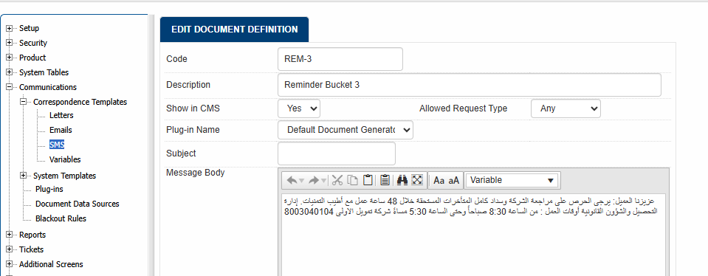

The required SMS templates are configured in the Application Setup.
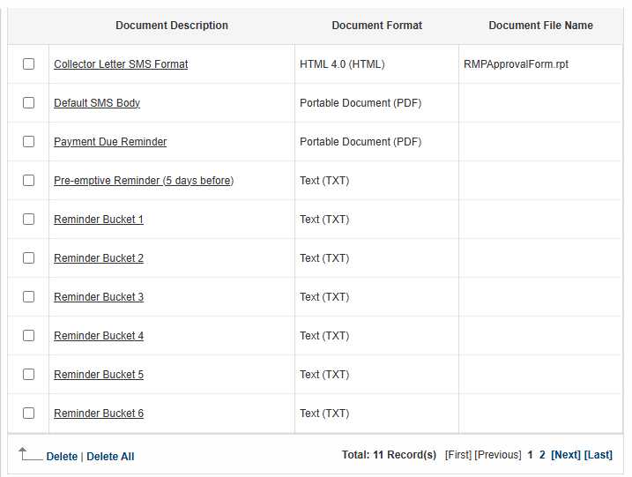

Workforce
The Workforce module of Advanced Collections explains the management of user and organizational units. It allows all users to view and send messages. Depending on the permission, manage employee records (including their permission and access), unlock employees, and deactivate employee access.
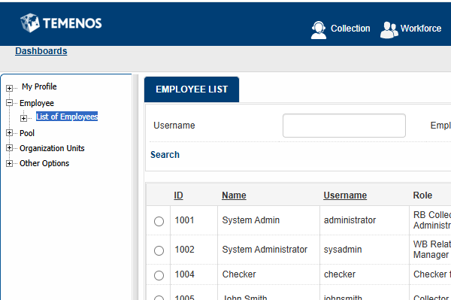

My Profile
To review the details of your employee record, click Workforce>My Profile. Messages and reminders can also be reviewed in this section.
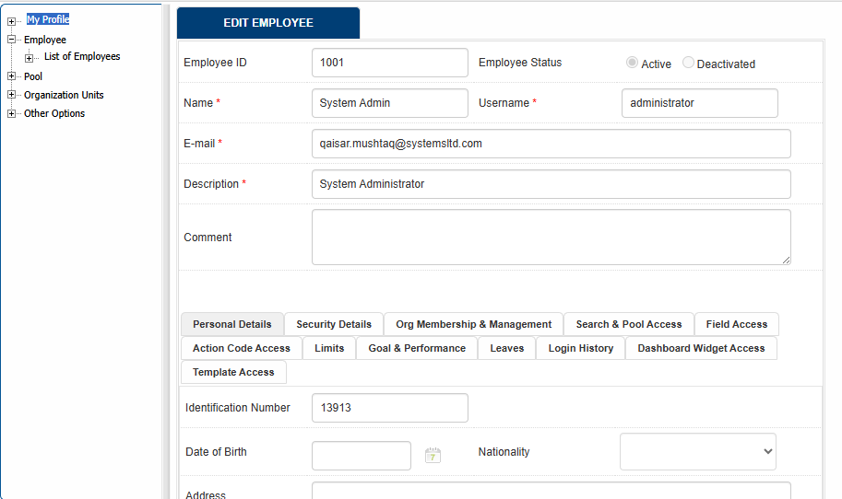

Managing Messages
To review messages and reminders, and send or broadcast message to a group or individuals, on the left side menu, go to Messages menu.
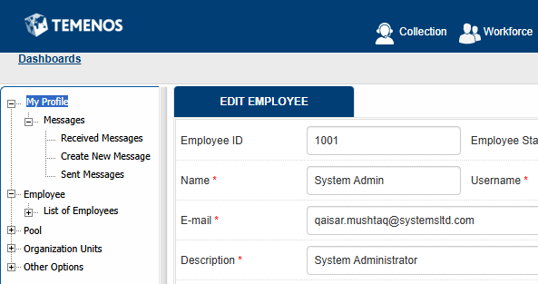

Review Received Messages
To review messages and reminders, click Workforce>My Profile>Messages>Received Messages. A pop-up browser will also appear if there is any unread message.
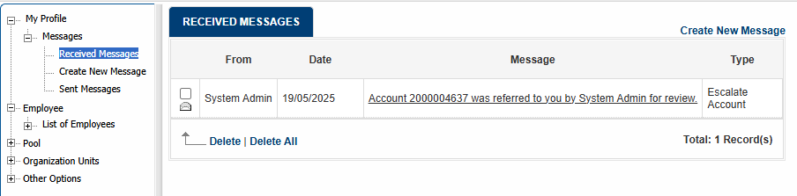

Create New Message
To send or broadcast message to a group or individuals, click Workforce>My Profile>Messages>Create New Message
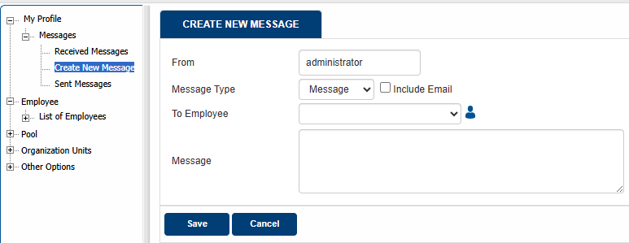

Review Sent Messages
To review sent messages, click Workforce>My Profile>Messages>Sent Messages
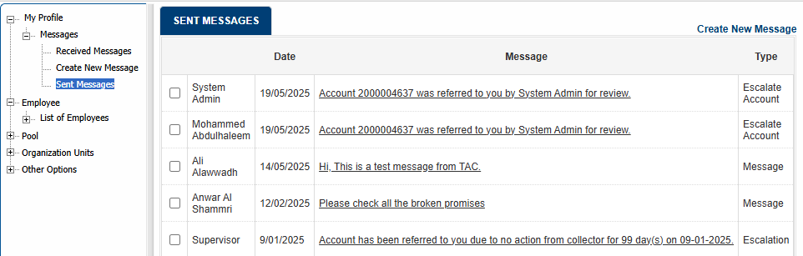

Managing User
To view and manage the list of users, click Workforce>Employee>List of Employee. The Employee List screen is displayed.
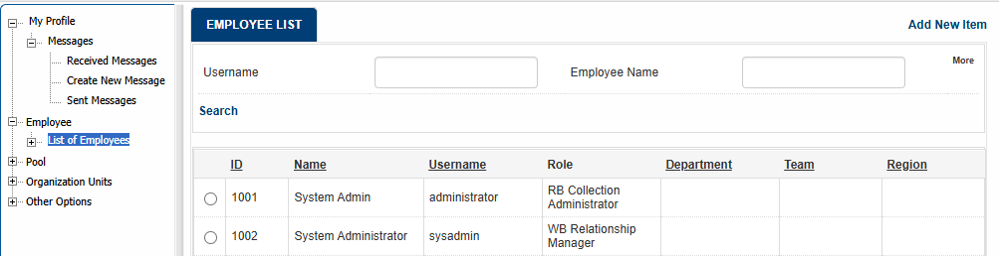

Search User List
To search from the List of User on [Employee List] Screen.
1. Enter any keyword available,
2. Click [more] for more advanced search,
3. Click [Search].
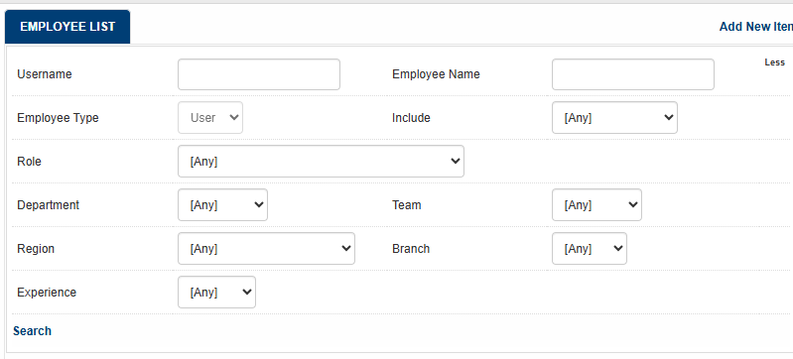

Managing User Profile
Add new or edit existing user will use the same form. To add new User, on [Employee List] screen,
1. Click [Add New item]
2. [Add New Employee] Screen will be displayed
To edit existing User, on Employee List screen
1. Select any user to be edited or reviewed by click the radio button
2. Click [Edit]
3. [Edit Employee] Screen will be displayed
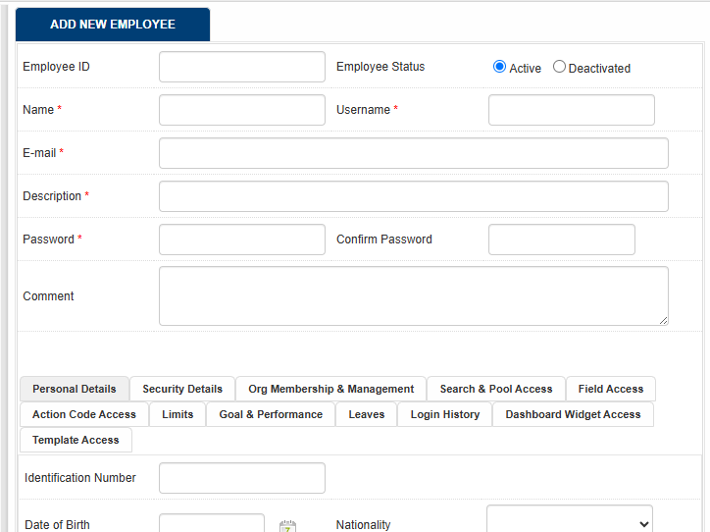

Setting Up User Personal Details
To set up User’s Personal Detail, on [Edit Employee] Screen, go to [Personal Details] Tab.
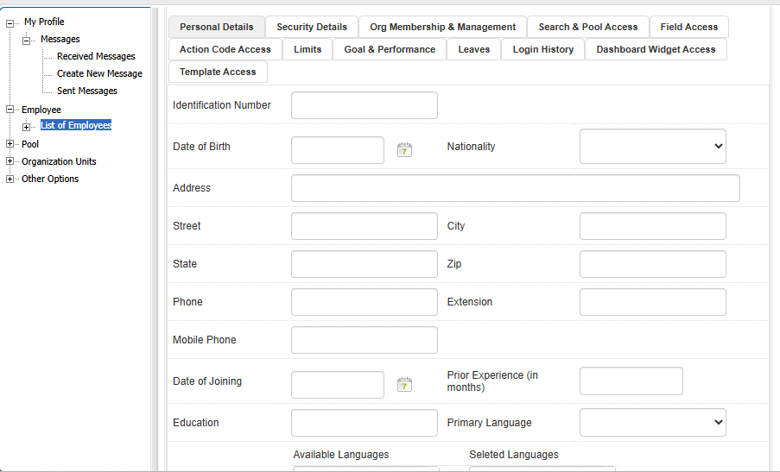

Managing User Permission and Other Security Details
To set up User’s System Access and Permission in the system, on [Edit Employee] Screen, go to [Security Details] Tab.
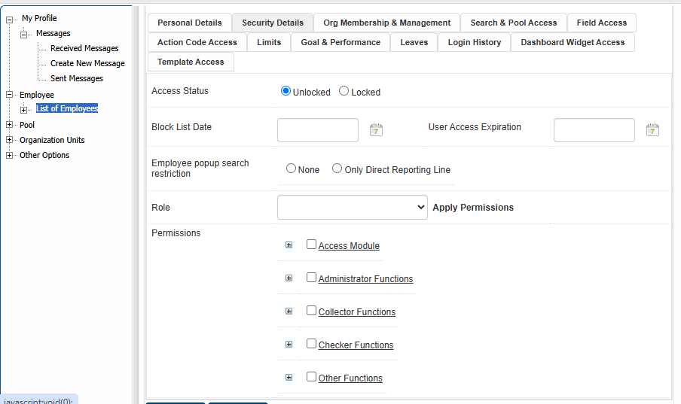

Managing Organization Membership
To view and update user’s organization membership (such as direct supervisor, administrative and geographical unit) and managed unit, click the [Org Membership & Management] tab. The user’s organization unit is used for various escalation process, access control and reporting.
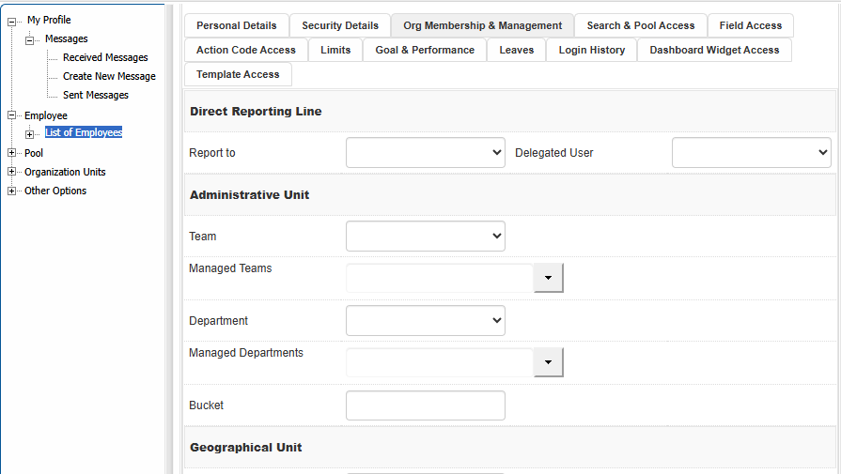

Managing Search and Pool Access
To view and update user’s queue sorting order, search result restriction, available search options and pools, click the [Search & Pool Access] tab.
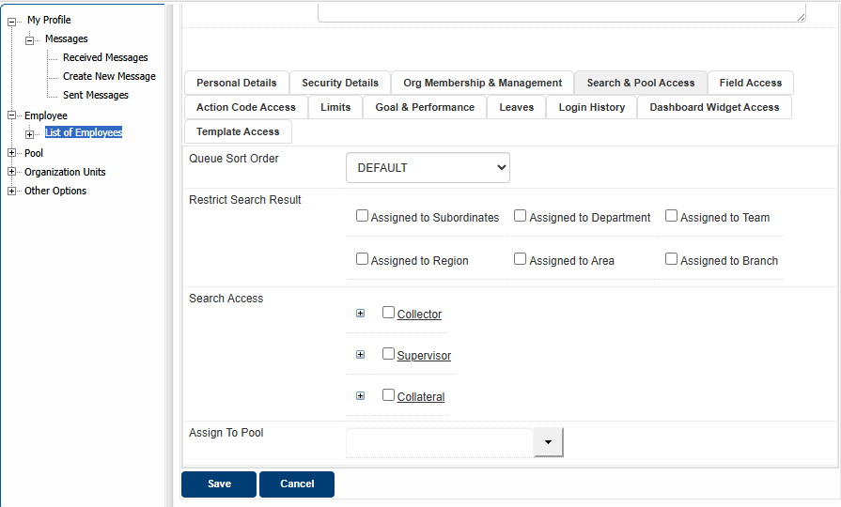

Assigning User Actions Access
To set up User’s Action Access, on [Edit Employee] Screen, go to [Action Code Access] Tab
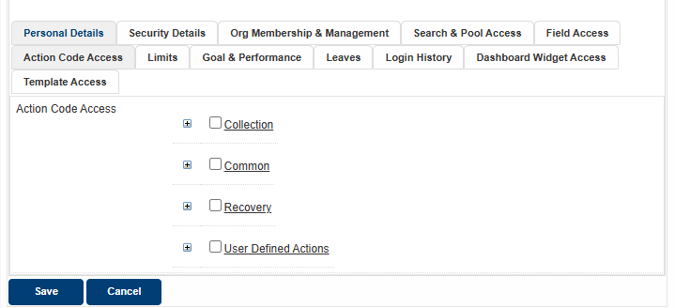

Monitoring Login History
To see login history or attempt, on [Edit Employee] Screen, go to [Login History] Tab
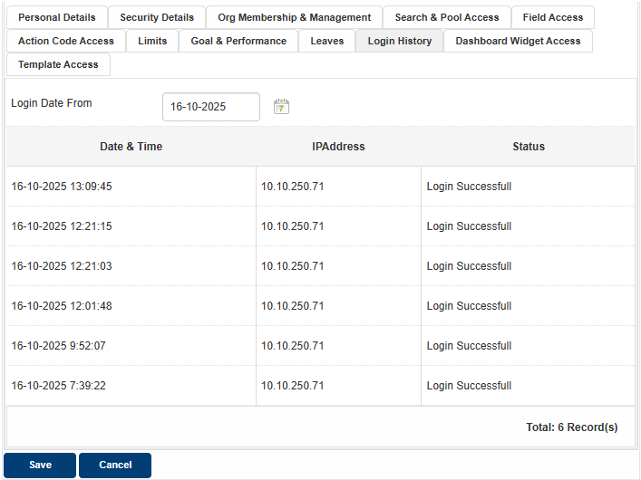

Managing Dashboard Widget Access
To give Dashboard Widget Access to specific User, on [Edit Employee] Screen, go to [Dashboard Widget Access] Tab
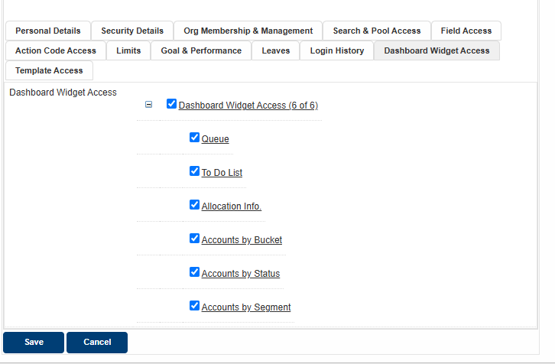

Managing Template Access
To give template access to specific User, on [Edit Employee] Screen, go to [Template Access] Tab. This feature enables an administrator to decide on the various templates that can be used by a specific user.
